Techno-Functional Specification Document

SuccessFactors Employee Central to SAP ERP HCM

Organizational Objects, Employee Master Data & Organizational Assignment Replication

Contents

1 Revision History 3

2 Reviewers 3

3 Sign Off 3

4 Distribution 4

5 Requirement 4

6 Assumption 8

7 Design 9

7.1 Replication Process 9

7.2 Source system: SuccessFactors Employee Central 11

7.3 Target system: SAP ERP HCM 12

7.4 Middleware: SAP Cloud Platform Integration 34

7.5 Field & Value Mapping 43

7.6 Tables, Programs, Execution & Monitoring 43

7.7 Maintenance 45

8 Connection 46

8.1 SuccessFactors Employee Central 46

8.2 SAP ERP HCM 46

8.3 SAP Cloud Platform Integration 46

9 Sample Files 46

10 Project Definition 46

10.1 Project Name 46

10.2 Migration Requirements 46

11 Appendix 47

11.1 Infotype Data Handling Reference 47

12 Open Items 47

1. Revision History

| **Date** | Author | **Version** | **Change Reference** |
| --- | --- | --- | --- |
| 09/03/2021 | Kristopher Saldivar | 0.1 | Initial |
| 12/22/2021 | Dona Canasa | 0.2 | Updated BADI Logic |
| 01/10/2022 | Dona Canasa | 0.3 | Took out Dynamic Actions in the BADI |
| 01/18/2022 | Dona Canasa | 0.4 | Updated BADI logic for National ID defaulting for contingent employees to 99999999 & including Dynamic Actions logic for infotype 0041. |
| 01/25/2022 | Dona Canasa | 0.5 | Updated field and portlet or Contingent Workers flang. Changed to isContingentWorker from Employment Info |
| 02/03/2022 | Dona Canasa | 0.6 | Updated default PERID for US Contingent Workers & Updated date type list for Poland in HPC. |
| 02/03/2022 | Airilene Concepcion | 0.7 | Updated List of scope Countries  Attached updated workbook |
| 02/09/2022 | Kristopher Saldivar | 0.8 | Updated IT0008 BAdI condition |
| 02/23/2022 | Kristopher Saldivar | 0.9 | Update IT0000 BADI  Update IT0041 Mex CAPT |
| 02/25/2022 | Kristopher Saldivar | 0.10 | Update IT0008 |
| 03/18/2022 | Kristopher Saldivar | 0.11 | Update IT0008 for fields IND01-IND01 |
| 03/19/2022 | Kristopher Saldivar | 0.12 | Update IT 6, 8, 9, 41 and 182 with the preventive logic to avoid gaps |
| 03/23/2022 | Kristopher Saldivar | 0.13 | Call BADI ZCL_IM_BADIHRPAD00INFTY after saving IT9001 |
| 04/14/2022 | Kristopher Saldivar | 0.15 | Update condition for IT0000 (HPC Mapping for GDNSK) |
| 04/27/2022 | Kristopher Saldivar | 0.16 | Update condition for IT0008 |
| 05/10/2022 | Kristopher Saldivar | 0.17 | Update Infotype 0002 secondary infotype |
| 05/19/2022 | Kristopher Saldivar | 0.18 | Update Infotype 0041 for Rehires |

1. Reviewers

| **Name** | Position |
| --- | --- |
|  |  |
|  |  |

1. Sign Off

| **Name** | Position | Signature |
| --- | --- | --- |
|  |  |  |
|  |  |  |

1. Distribution

| **Copy No.** | Name | **Position** |
| --- | --- | --- |
|  |  |  |
|  |  |  |
|  |  |  |
|  |  |  |

1. Requirement

With SuccessFactors Employee Central (EC) the source of truth of HR Organizational & Employee Data moving forward, TENNECO would require org & employee details to flow to their local payroll systems (4), SAP ERP HCM. SAP ERP HCM needs to be synched with the current org & employee data to ensure accurate and efficient payroll processing.

Below are the countries in scope:

* SAP ERP Systems
  + H1P MPPS
    - Germany
    - Argentina
    - Belgium
    - Brazil
    - Japan
    - China
    - Czech
    - France
    - Denmark
    - Italy
    - India
    - Mexico
    - South Africa
    - Spain
    - Thailand
    - Russia
    - Romania
    - Canada
    - Hungary
    - South Korea
    - Australia
    - ~~Morocco~~
    - ~~Vietnam~~
    - ~~Philippines~~
    - Singapore
    - Turkey
    - Taiwan
    - Ukraine
    - Colombia
    - Egypt
    - Costa Rica
    - Bulgaria
    - Croatia
    - Finland
    - Greece
    - Guatemala
    - Netherlands
    - Norway
    - Serbia
    - Montenegro
    - UAE
    - USA
    - UK
    - Sweden
    - Poland
  + H1P CAPT
    - Germany
    - Argentina
    - Belgium
    - Brazil
    - Japan
    - China
    - France
    - Portugal
    - South Africa
    - Spain
    - Thailand
    - Russia
    - ~~Romania~~
    - Canada
    - Hungary
    - South Korea
    - ~~Australia~~
    - Morocco
    - Vietnam
    - Philippines
    - Singapore
    - Turkey
    - ~~Taiwan~~
    - ~~Ukraine~~
    - ~~Colombia~~
    - ~~Egypt~~
    - ~~Costa Rica~~
    - ~~Bulgaria~~
    - ~~Croatia~~
    - ~~Finland~~
    - ~~Greece~~
    - ~~Guatemala~~
    - ~~Netherlands~~
    - ~~Norway~~
    - ~~Serbia~~
    - ~~Montenegro~~
    - USA
    - Czech
    - Sweden
    - Mexico
    - Poland
    - UK
    - Italy
    - India
  + HPC
    - Germany
    - UK
    - Poland
    - Mexico
  + VPC
    - Germany
    - UK
    - Mexico

SAP had provided an Integration add-on for SAP ERP HCM and EC, PA_SE_IN, facilitated by SAP Cloud Platform Integration (SCPI) for this requirement. Full information on the standard implementation of the Integration add-on is found on the attached Implementation guide:

For Organization Data:



Reference Link: <https://help.sap.com/viewer/45372a91942140518d37370208c8525d/1902/en-US>

For Employee Data:



Reference link: <https://help.sap.com/doc/435c6837038d4eb4b1a39947411d5a3e/1902/en-US/SF_EC_ERP_EE_Data_Org_Assignm_HCI_en-US.pdf>

This document will provide the specification of the standard implementation and the additional customizing or development as required for TENNECO seamless HR data transfer from EC to SAP HR Payroll.

**Considerations (business logic for each events):**

Hire

Rehire

Termination

Data Changes

Organizational Assignment

Inter/Intra company transfer

Contingent Worker

Global Assignment

Employment Changes

Dynamic Actions

1. Assumption

The standard SAP SuccessFactors Employee Central to ERP Employee and Organizational Data Integration Package will be utilized for this interface. The package contains 2 Integration flows in SAP Cloud Platform Integration:

1. SAP SuccessFactors Employee Central to ERP Employee Data and Organizational Assignment
2. SAP SuccessFactors Employee Central to ERP Generic Object.

The Organizational Data replication will be limited to the following Objects for the infotypes specified below, limited in the creation of object relationships:

| **Infotype** | **Object Type** | **EN Description** |
| --- | --- | --- |
| 1000 | **S** | Position |

The Employee data replication will be limited to the following infotypes:

| **Infotype** | **Description** |
| --- | --- |
| 0000 | Action |
| 0001 | Organizational Assignment |
| 0002 | Personal Data |
| 0006 | Address |
| 0008 | Basic Pay |
| 0009 | Bank Details |
| 0041 | Date Specifications |
| 0105 | Communication IDs |
| 0182 | Alternative Names Asia |
| 0302 | Additional Actions |
| 9001 | Global HR Information |

Notes:

* These infotypes are still subject for discussion if will be included as part of replication.

** Some of the Infotypes are not part of the standard mapping but can be accommodated through Business integration Builder (BIB) or built-in BADIs from the Integration Add-on in SAP.

*Please refer to Business Add-Ins (BADI) section*

*** Please refer to the attached Infotype replication workbook for more details.

1. Design
   1. Replication Process

Replication process of the Organization Management Objects (Foundation Objects). Here’s the step-by-step process:

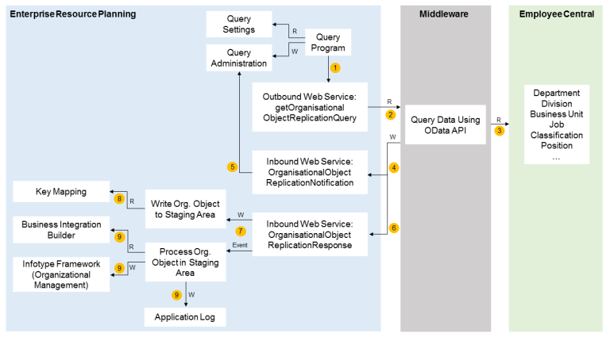

1. The query program in the SAP ERP HCM system, Create and Execute Organizational Object Replication Query (***RH_SFIOM_ORG_OBJ_REPL_QUERY***), reads the settings (such as the filtering information) you have defined in Customizing and calls the outbound web service ***getOrganisationalObjectReplicationQuery***. It also updates the query administration tables.
2. The outbound web service sends the query to SAP CPI. The filter settings tell SAP CPI which data records are to be replicated – for example, only active records if you've defined a suitable filter.
3. SAP CPI requests the corresponding data from Employee Central using the OData API.
4. The middleware calls the inbound web service ***OrganisationalObjectReplicationNotification*** in the SAP ERP HCM system to send a notification about the replication status.
5. The inbound web service updates the status in the Administration of Organizational Object Query (***SFIOM_QRY_ADM***) table. This table stores an entry for each object type, which is updated with each replication run. The status can be Sent, Successful, or Failed.
6. SAP CPI calls the inbound web service ***OrganisationalObjectReplicationResponse*** in the SAP ERP HCM system to pass over the data it has received from Employee Central.
7. The inbound web service stores the organizational object requests transferred from Employee Central in the staging area and triggers the ***SAP_SFIOM_ORG_STRUC_RPRQ_CREATED*** event.
8. While storing the organizational object requests in the staging area, the SAP ERP HCM system reads the key mapping to map Employee Central keys with SAP ERP HCM keys.
9. Once the database update program registered on the ***SAP_SFIOM_ORG_STRUC_RPRQ_CREATED*** event has run, the SAP ERP HCM system creates or updates corresponding infotype records in Organizational Management and updates the application log. When doing so, it uses this field mapping settings you have made in the Business Integration Builder (or, in the Generic Object Replication with Object-Specific Processing use case, the default field mapping provided for the default objects).

Replication process of the Employee Master Data. Here’s the step-by-step process:

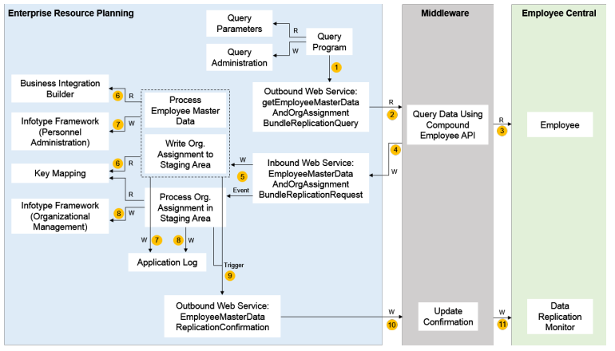

Here's how this process runs:

1. The query program in the SAP ERP HCM system, Create and Execute Employee Master Data and Org. Assignment Query (***ECPAO_EE_ORG_REPL_QUERY***), reads the parameters you have defined in Customizing and calls the outbound web service ***getEmployeeMasterDataAndOrgAssignmentBundleReplicationQuery***. It also updates the query administration tables.
2. The outbound web service sends the query to SAP Cloud Platform Integration.
3. SAP Cloud Platform Integration requests the corresponding data from Employee Central using the Compound Employee API.
4. SAP Cloud Platform Integration calls the inbound web service ***EmployeeMasterDataAndOrgAssignmentBundleReplicationRequest*** in the SAP ERP HCM system to pass over the data it has received from Employee Central.
5. The inbound web service triggers processing of the employee master data transferred from Employee Central in the SAP ERP HCM system. It also stores the organizational assignment requests transferred from Employee Central in the staging area and triggers the ***SAP_SFIOM_EE_ORGAS_RPPQ_CREATED*** event.
6. While processing the employee master data and storing the organizational assignment requests in the staging area, the SAP ERP HCM system reads the key mapping to map Employee Central keys with SAP ERP HCM keys. It also reads the Customizing settings you have made in the Business Integration Builder.
7. Once the employee master data has been processed, the SAP ERP HCM system creates or updates corresponding infotype records in Personnel Administration and updates the application log.
8. Once the database update program registered on the ***SAP_SFIOM_EE_ORGAS_RPPQ_CREATED*** event has run, the SAP ERP HCM system creates or updates corresponding infotype records in Organizational Management and updates the application log.
9. The processing of employee master data and organizational assignments triggers the outbound web service ***EmployeeMasterDataReplicationConfirmation*** to tell Employee Central whether data transfer was successful or not.
10. The outbound web service passes over the corresponding success or error confirmation to SAP Cloud Platform Integration.

Note: The Process flow and diagram are taken from section 5.1.1 of the Implementation Guides attached in section 5 as per SAP Integration Standard.

* 1. Source system: SuccessFactors Employee Central

SuccessFactors Employee Central (EC) will be the Master for Employee Data as part of Project 4 Implementation. Thus, all application requiring Employee Data for other HR and downstream processes would need to integrate with EC. To enable integration with EC, a user needs to be created with permissions granted to use Successfactors’ ODATA API and SFAPI.

The following steps needs to be taken to ensure required authorizations for API usage are granted to the Integration user that will be utilized by the data replication:

1. Under ***User Permissions***, select the ***General User Permissions*** category.
2. Select the checkbox for the ***SFAPI User Login*** permission.
3. Under ***Administrator Permissions***, select the ***Manage Integration Tools*** category.
4. Select the checkbox for the ***Admin Access to OData API*** permission.
5. Under ***Administrator Permissions***, select the ***Employee Central API*** category.
6. Select the checkboxes for the following permissions:
   1. ***Employee Central Foundation SOAP API***
   2. ***Employee Central HRIS SOAP API***
   3. ***Employee Central Foundation OData API (read-only)***
   4. ***Employee Central HRIS OData API (read-only)***
   5. ***Employee Central Foundation OData API (editable)***
   6. ***Employee Central HRIS OData API (editable)***

SAP ERP HCM would require the picklist file from EC to establish the value mapping. Download the picklists that you want to import from Employee Central and store the picklist file in the comma separated values (CSV) format on a server or on your local disk. Here's how you download picklists:

* 1. Go to the ***Admin Center*** and choose the ***Picklists Management*** tool.
  2. Choose ***Refresh***.
  3. Choose ***Export all picklist(s)***.
  4. Choose ***Submit***.
  5. Save and extract the exported picklist file.

Refer to the Workbooks for all configuration requirements in EC.

* 1. Target system: SAP ERP HCM

SAP ERP HCM will remain as the Time Management and Payroll system for TENNECO. Thus, all relevant Org objects, employee data & org assignment is required by this system to continue functioning as such.

To enable integration with SAP ERP HCM, a data replication user in SAP ERP HCM needs to be created with permissions required for the web services used in organizational assignment and organizational objects.

**Data Replication User Authorization**

Data Replication User would need authorization to execute the replication process:

● Checking the key mapping in table SFIOM_KMAP_OSI

● Accessing the staging area with the Replication Request Monitor or Replication Request Viewers

● Scheduling the program which processes the replication requests in the staging area and posts the results to the database.

● Changing the organizational model (also required for being able to schedule the background job for processing replication requests in the staging area).

The following template roles have been provided to enable the Data Replication User appropriate authorization to execute all the activities required by the replication process.

● SAP_HR_SFIOM_WEBSERVICES

● SAP_HR_SFIOM_PROCESSING

The following steps needs to be taken to ensure required authorizations for Web Service used for organizational assignment and organizational objects:

1. Go to the Role Maintenance (PFCG) transaction in your SAP ERP HCM system
2. Set up the data replication user. A technical user of type B (System User) with specific permissions and restrictions is needed to ensure that the middleware can successfully communicate with the SAP ERP HCM system.
   1. Copy the template role SAP_HR_SFIOM_WEBSERVICES to the customer namespace.
   2. Assign the copied role to the data replication user.
3. Set up the user needed for processing the replicated data.

a. Copy the template role SAP_HR_SFIOM_PROCESSING to the customer namespace.

b. Set up permissions for the copied role to suit your specific requirements (for example, if you want to restrict permissions to specific relationships).

c. Assign the copied role to the user who processes the data replicated from Employee Central in the SAP ERP HCM system.

**SAP Webservices for replication**

There are 2 types of webservices utilised for data replication – outbound and inbound webservices. Outbound webservices are services calling endpoints exposed out of SAP ERP HCM. Inbound webservices are services exposed for external applications to consume. The webservices that is required to be enabled for the data replication process to work are:

**Outbound Webservices**

* ***getOrganisationalObjectReplicationQuery_Out***

This SAP ERP HCM outbound service triggers data replication from Employee Central. It contains a query that is based on the configuration and filter settings you made in the SAP ERP HCM system. The service first reaches the middleware, which then triggers an OData API call to query the data from Employee Central. The filter settings tell SAP CPI which data records are to be replicated – for example, only active records if you've defined a suitable filter. The default objects queried from Employee Central are: business units, divisions, departments, job classifications, and positions. Depending on the settings you make in SAP ERP HCM also other organizational objects are queried by this web service.

* ***EmployeeMasterDataReplicationConfirmation_Out***

This SAP ERP HCM outbound service updates the Employee Central Data Replication Monitor with information about whether data transfer to the SAP ERP HCM system was successful or not.

* ***getEmployeeMasterDataAndOrgAssignmentBundleReplicationQuery_Out***

This SAP ERP HCM outbound service triggers data replication from Employee Central. It contains a query that is based on the configuration you made in the SAP ERP HCM system. The service first reaches the middleware, which then triggers a Compound Employee API call to query the data from Employee Central. The service has a Processing Parameter node, which contains a list of the processing parameters you have configured in SAP ERP HCM.

**Inbound Webservices**

* ***OrganisationalObjectReplicationResponse_In***

This SAP ERP HCM inbound service returns information back to the SAP ERP HCM system. It contains the response, that is, the result of the query made to Employee Central.

* ***OrganisationalObjectReplicationNotification_In***

This SAP ERP HCM inbound service returns a notification from Employee Central. That is, status information about the query, together with error information if applicable.

* ***EmployeeMasterDataAndOrgAssignmentBundleReplicationRequest_In***

This SAP ERP HCM inbound service returns information back to the SAP ERP HCM system. It either contains the response, that is, the result of the query made to Employee Central in the Base64 XML format. Or it contains a notification, that is, status information about the query, together with general, employee-independent error information. Note that either the response or the notification is transferred, but not both together. This service also contains the time stamp of when the Compound Employee API started processing. This time stamp is used to determine the last modified date for the next call. This service also has a Processing Parameter node, which contains a list of parameters from Employee Central. You can use these parameters to further control the processing.

* ***EmployeeMasterDataAndOrgAssignmentPushNotification_In***

This SAP ERP HCM inbound service tells the SAP ERP HCM that a push event was carried out in Employee Central that is relevant for the SAP ERP HCM system. The notification contains the list of employees, that is, a list of user IDs or external person IDs. It also contains the transformation template group to be used in SAP ERP HCM.

**To enable outbound webservices**

1. Copy the URL used for the communication from SAP ERP HCM to SAP CPI from the Integration Content Monitor in SAP CPI.

***SAP CPI URL per webservice:***

|  |  |
| --- | --- |
| Webservice: | ***getOrganisationalObjectReplicationQuery_Out*** |
| Development: | tbd |
| Test: | tbd |
| Production: | tbd |

|  |  |
| --- | --- |
| Webservice: | ***EmployeeMasterDataReplicationConfirmation_Out*** |
| Development: | tbd |
| Test: | tbd |
| Production: | tbd |

1. Go to the SOA Management (SOAMANAGER) transaction in your SAP ERP HCM system and choose Web Service Configuration.
2. Search for the CO_SFIOMX_ORG_OBJECT_REPL_QRY consumer proxy and select the corresponding entry in the search result.
3. Choose Create Manual Configuration and create a new logical port.
4. Select the User ID / Password authentication option and enter the user ID and password of your SAP Cloud Platform Integration communication user.
5. Set up the messaging

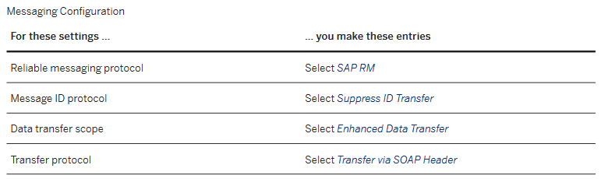

1. Set up transport settings

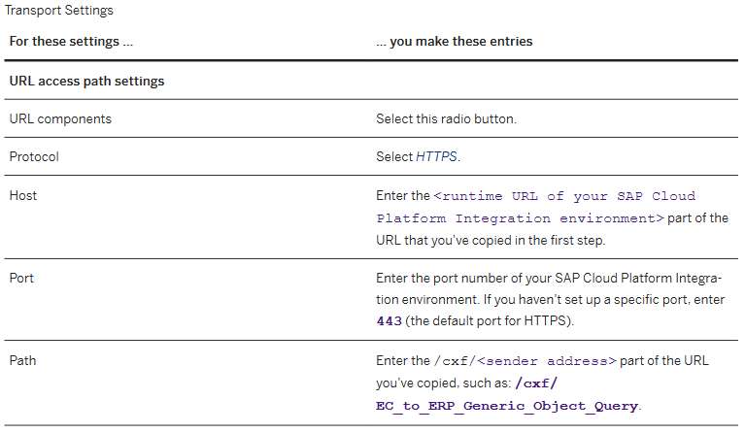

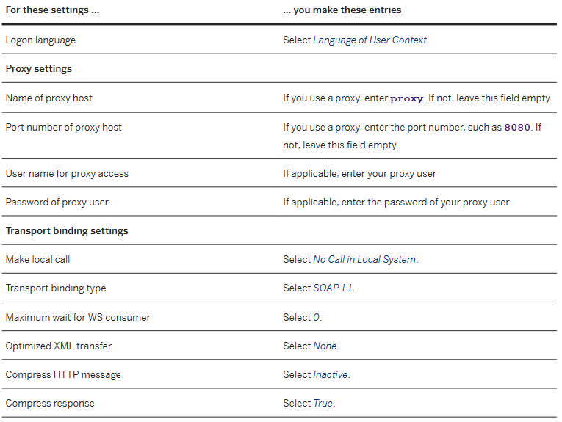

1. To set your new logical port as default port, select the entry end choose Set ***Log. Port Default***.
2. Leave the other fields empty and terminate the Web Service Configuration setup.
3. Test outbound connectivity from SAP ERP HCM to SAP Cloud Platform Integration.
   1. Press the Ping Web Service button.You will get an HTTP ERROR 405. Don't worry, from a technical point of view everything is alright. You get this error message because the Ping can't fill the business content of the web service.
   2. If you get this or a similar error message when you start the Ping web service, you are most probably missing one or more certificates: *SRT Framework exception: Service Ping ERROR: Error when calling SOAP Runtime functions: SRT: Processing error in Internet Communication Framework: ("ICF Error when receiving the response: ICM_HTTP_SSL_ERROR")*. This error message is generated at technical handshake between SAP ERP HCM and the middleware systems, at the level of the Internet Communication Framework (ICF).

**To enable inbound webservices**

1. Go to the SOA Management (SOAMANAGER) transaction in your SAP ERP HCM system.
2. Choose Simplified Web Service Configuration
3. Enter the web service definition name in the Search Pattern field and choose Go.
4. In the result list, select the User Name / Password (Basic) checkbox for the web service definition, then choose Save.

**Securing communications**

To enable secure HTTPS communication between SAP ERP HCM and SAP CPI, the root certificate of SAP CPI needs to be stored in the Trust Manager (transaction STRUST) in SAP ERP HCM.

For connections initiated by SAP Cloud Platform Integration to the SAP ERP HCM system, the root certificate from the SAP ERP HCM system needs to be added in the keystore in the SAP Cloud Platform Integration tenant.

**Personnel Administration & Organization Management Integration**

In SAP ERP HCM system integration between Organizational Management (OM) and Personnel Administration (PA) is called PA/PD integration. You can use PA/PD integration if you replicate employee master data and organizational assignment data from EC to SAP ERP HCM to synchronize organizational data (position, job, org unit, cost center) between the Relationships (1001) infotype in Organizational Management and the Organizational Assignment (0001) infotype in Personnel Administration.

To activate/enable the PA/PD Integration in SAP ERP HCM System following steps needs to be done:

* Integration between Organizational Management and Personnel Administration is active if the value of the **PLOGI ORGA** switch in table **T77S0** is set to **“”**. Integration can be restricted for subsets of employees using the Control: Integration of Personnel Planning and Master Data Management (PLOGI) feature. You can find these settings in SAP Customizing for **Personnel Management**, under **Organizational Management** >>**Integration**>>**Integration with Personnel Administration>>Set up Integration with Personnel Administration**. **Choose Basic Settings to set the switch or Participate in Integration to maintain the PLOGI feature**.
* Most of the time, we have direct mapping from one EC field to one SAP field, but in some cases, we need to define customer-specific settings. To define Customizing activities and Business Add-Ins (BAdIs) in the integration of SAP ERP HCM and SAP SuccessFactors Employee Central (PA_SE_IN) add-on. In SAP HCM ERP go to the Customizing: Execute Project (SPRO) transaction, go to SAP Reference IMG. In the SAP Customizing Implementation Guide structure open **Personnel Management**>>**Integration with SuccessFactors Employee Central**>>**Business Integration Builder.**

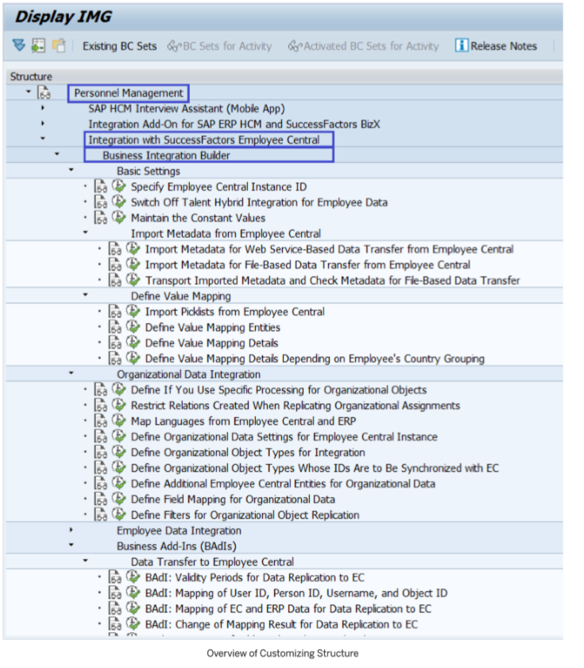

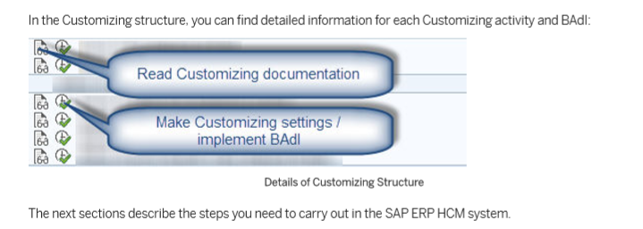

**New Infotype Framework for Integration Between Organizational Management and Personnel Administration (PA/PD Integration)**

Configuration for the New Infotype Framework for PA/PD integration will be Enable to synchronize organizational data between the Relationships (1001) and the Organizational Assignment (0001) infotypes.

To enable New Infotype Framework for PA/PD integration following are steps are required to be done.

1. In Customizing for Personnel Management, choose **Integration with SuccessFactors Employee Central**>>**Business Integration Builder**>>**Organizational Data Integration**>>**Enable Use of New Infotype Framework When Processing Replicated Org. Data .**
2. Choose New Entries and enter the following data:

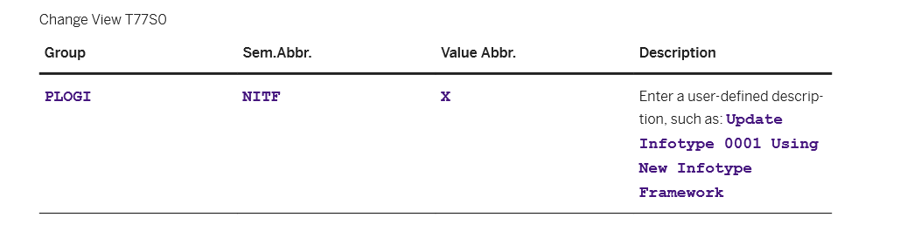

1. Save and transport your entry.

**Specify Employee Central Instance ID**

Employee Central Instance ID in SAP HCM ERP system represents EC configuration and refers to the metadata we use in Employee Central and to basic settings for data Transfer between ERP and EC.To define an Instance ID in ERP:

Go to the Specify Employee Central Instance ID Customizing activity (view **V_ECPAO_COMPNY_EE**).

1. Enter an ID and a description = tennecoT2
2. Map UserID to PERNR
3. Map Username to Infotype 0105/0001
4. Map Person ID to Infotype 0709
5. Employment for International Transfer: Create New Employment for International Transfer

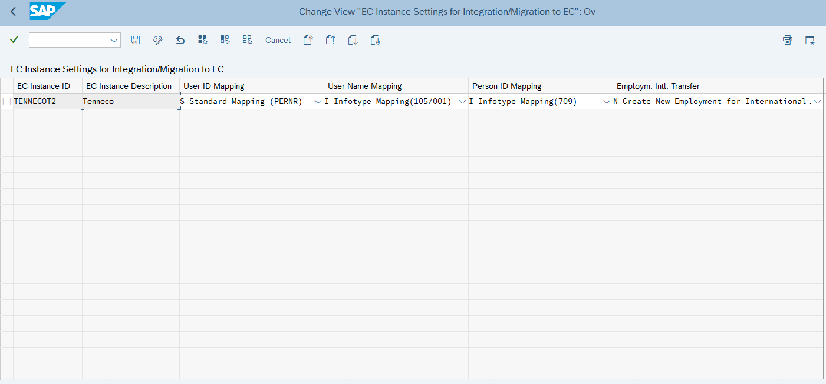

**Import Metadata from Employee Central**

We Import metadata such as field names and field descriptions from EC to SAP HCM ERP system. To do so, you use the *Import of Metadata from Employee Central Using XML File* (**ECPAO_ECTMPL_METADATA_WRITER**) program.

*** Note You can only use this program to import metadata for web service entities.

**Define Value Mapping**

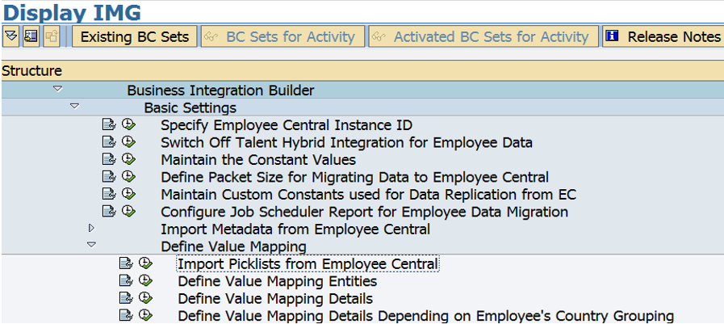

Please refer on the attached file section 7.5 Value Mapping.

**Importing Picklist From EC**

We import picklists and picklist values from EC to the SAP ERP HCM system to use them in Customizing when mapping EC field values to values of SAP ERP HCM fields. To do this we use Import of Picklists from Employee Central **(ECPAO_PICKLIST_WRITER)** program.

Before you run the picklist writer report, you must set the mode of the picklist file in the view V_ECPAO_CONSTANT. Set "X" for Mode of Picklist File value. If the switch is set to X, then MDF picklist without Option ID is chosen. And if this switch is set to Y, then the new MDF picklist with Option ID is chosen. If you leave the field blank, then the legacy picklist would be chosen.

Procedure:

1. Download pick list in EC
2. Run ECPAO_PICKLIST_WRITER program, select your Employee Central instance and the picklist file that you want to upload.

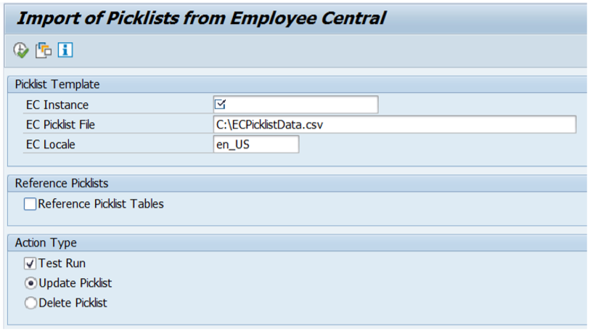

1. Enter the locale of the picklist labels that you want to import.
2. Select the Update Picklist checkbox to import picklists and picklist values.
3. Clear the Test Run checkbox and execute the program to upload the data from the Employee Central picklist file into the following tables:

* Picklists Imported from Employee Central (ECPAO_PIKLST_ENT)
* Picklist Values Imported from Employee Central (ECPAO_PIKLST_VAL)

**Define Value Mapping Entities**

A value mapping entity combines a set of value mappings for a specific purpose (for example, gender code value mappings). You define value mapping entities in the Define Value Mapping Entities Customizing step (view V_ECPAO_VALUENTY). The easiest way to create value mapping entities is to copy the sample entities by choosing the Copy Sample Value Mapping pushbutton.

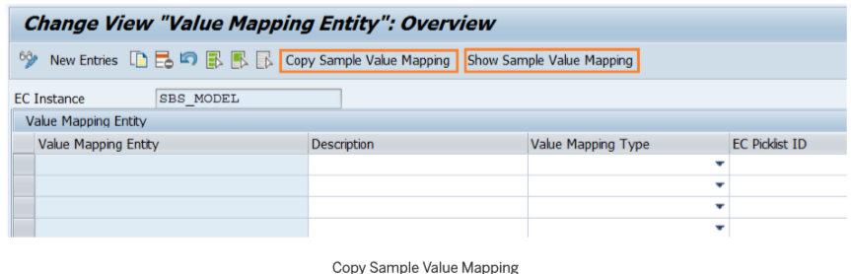

You'll get a list of all standard entities provided for the integration, which you can adjust to your needs

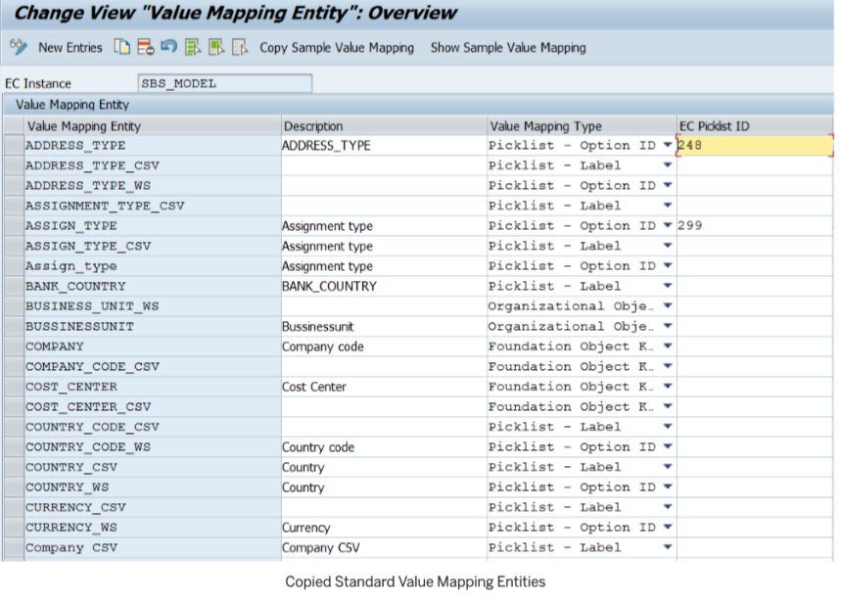

Procedure:

1. To create a value mapping entity from scratch, enter a name and description. If you want to use a standard entity, you need to keep its name, but you can adjust the description.
2. Specify how the values are to be mapped. If you want to use a standard entity, we recommend that you use the suggested mapping types. If you want to specify a mapping type, you have the following options: 3

○ Picklist mapping using the Option ID field from the picklist Use this type if the picklist value you want to map is an option ID. This is the case for most of the picklists.

○ Picklist mapping using the External Code field from the picklist Use this type if the picklist value you want to map is an External Code. This is the case for most of the picklists.

1. 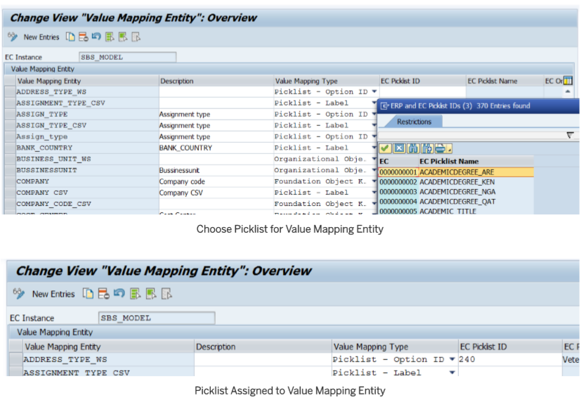To make available picklist values you've imported to the SAP ERP HCM system from Employee Central in the value mapping details, assign a picklist to the value mapping entity.

This enables you to choose the imported picklist values in the Employee Central Key field when you map the values. If you don't assign a picklist, you can still enter keys in the Employee Central Key field, but you can't choose from the imported picklist values.

1. To make available input help values from an infotype field in the value mapping details, specify the SAP ERP HCM value help.

This is a combination of the technical name of the infotype table (such as PA0002) and the technical name of the infotype field (such as GESCH), connected with a hyphen (as in PA0002-GESCH). This means that you can choose the input help values from the Gender Key (GESCH) field of the Personal Data (0002) infotype in the ERP Key field when you actually map the values. It does not mean that you can only use the value mapping entity for the GESCH field. If you want to use a sample entity, we recommend that you use the suggested SAP ERP HCM value helps.

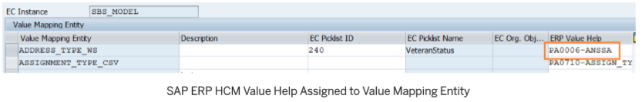

**Define Value Mapping Details**

The value mapping details map SAP ERP HCM values to the corresponding EC values.

Procedure:

1. Go to the Define Value Mapping Details Customizing activity (V_ECPAO_VALENTY).
2. Map SAP ERP HCM keys and the corresponding Employee Central keys.

If the value mapping entity has a picklist ID and a SAP ERP HCM value help assigned, you can select suitable picklist values in the EC Key field and corresponding input help values in the ERP Key field.

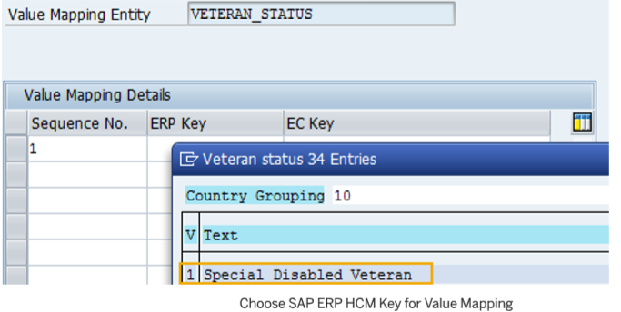

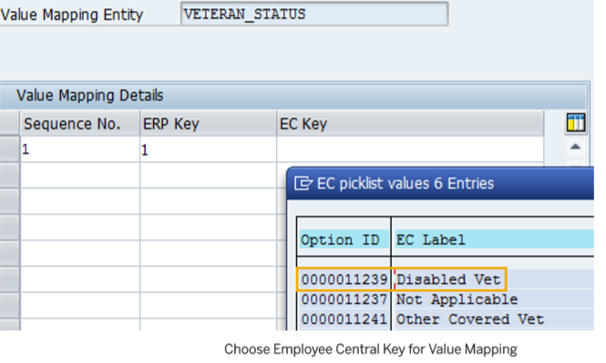

**Define Value Mapping Details Depending on Employee's Country Grouping**

This is similar to Define Value Mapping Details, but it is country specific.

1. Go to the Define Value Mapping Details Depending on Employee's Country Grouping Customizing activity (V_ECPAO_VALENTYC).
2. Map SAP ERP HCM keys and the corresponding Employee Central keys as described in the previous section, and additionally assign ISO codes.

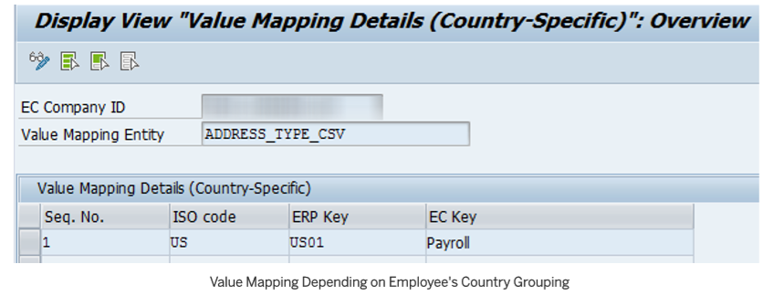

**Generic Processing for Organizational Objects**

For this configuration we will utilize Generic Object, configuration-based processing for all organizational objects replicated from Employee Central.

Procedure to change the switch to define Processing of Organizational Objects.

1. go to the Define If You Use Specific Processing for Organizational Objects
2. set the SFSFI SPOMP switch to **Blank**

**Business Add-Ins (BADI)**

**Change Infotype Data**

If you have to change infotype data after replication do not implement the BAdI : Master Data, Infotype Database update logic (HRPAD00INFTYDB). Doing so will lead to retro-calculation to the start date of each changed record. Instead, use the BAdI Process Infotype ECPAO_IN_EXT_PROCESS_INFOTYPE.

In the IMG structure open SAP Customizing Implementation Guide>>**Personnel Management**>>**Integration with SuccessFactors Employee Central** >>**Business Integration Builder**>>**Business Add-Ins (BAdIs)**>>**Data Transfer from Employee Central**>>**BAdI: Change of Infotype record during EC to ERP replication**

Procedure:

* **Change Infotype Data**

1. In the IMG structure open SAP Customizing Implementation Guide **Personnel Management**>>**Integration with SuccessFactors Employee Central**>>**Business Integration Builder**>>**Business Add-Ins (BAdIs)**>>**Data Transfer from Employee Central BAdI: Change of Infotype record during EC to ERP replication**.
2. You implement this BAdI to change the content of the PA Infotypes. With this BAdI ECPAO_IN_EXT_PROCESS_INFOTYPE you can modify the infotype records created from EC system.
3. This BAdI is only called for those infotype which are configured as part of the BIB configuration.

**Implemented BADI:**

* **Enhancement Implementation:** To be supplied by developer
* **BADI Implementation:** To be supplied by developer
* **Class:** To be supplied by developer

Employees with Replication Category ***E*** (No Replication) does not require data replication to SAP. As the field Replication Category is a custom field, this cannot be used as a filter in the Data Replication query as a standard. To ensure no updates will be made to existing records in SAP, current data in the Infotype tables need to be queried and replace the contents of PNNNN_PRIMARY_TAB. Below is the generic Logic for all infotypes to acquire the Replication Category from the payload:

* + Get First Transmission Start Date (FTSD), field CUT_OVER_DATE from table ECPAO_TEMPL_SET, with the condition field IS_EE_INBOUND is **X**
  + Retrieve Job information payload using Entity ID ***WS_4***, get fields **startDate**, ***customString18*** and its corresponding field value.
  + If the Replication category value is ***E***, query all records in SAP from the corresponding infotype table (based on BADI importing parameter INFOTYPE) effective on and after the FTSD.
    - Replace the records in the PNNNN_PRIMARY_TAB with the values retrieved from the Infotype table for periods when the Replication category is ***E***.
    - Check PNNNN_PRIMARY_TAB for gaps or overlaps. Sort table PNNNN_PRIMARY_TAB by End Date & Start Date descending.
    - Remove duplicates comparing Start Date & End Date
    - Loop into PNNNN_PRIMARY_TAB and compare Start Date of the previous record to the End Date of the next record. Next record End Date should be the day before the Start Date of the previous record, if not change the next record end date to the day before the Start Date of the previous record.
    - Check if the next record start date is greater than the end date, if so, remove the record from the table. Repeat the previous step to ensure no gaps in the record.
    - Please refer to the attached guide in section 11.1 on how the data would look and how data handled for these steps.
  + If there’s no record found from the Infotype tables, delete contents of PNNNN_PRIMARY_TAB.
  + Processing after this BADI will validate if there’s a change from EC by comparing contents from PNNNN_PRIMARY_TAB to the current SAP records. If they are the same, no updates will be made.

When an employee is a contingent worker, only 4 Infotypes will be created – 0000, 0001, 0002 & 9001. National ID is defaulted to ***999999999*** for US Contingent Employees. For these 4 infotypes, the default values defined in the mapping document from section 7.5 should be used to avoid data errors.

Logic:

* + Check if the employee is Contingent for the period
    - Retrieve Job information payload using Entity ID ***WS_4***, get fields ***startDate and countryOfCompany*** with its corresponding field value
    - Retrieve Employment information payload using Entity ID ***WS_3***, get field ***isContingentWorker*** with its corresponding field value.
    - If ***isContingentWorker*** value is ***TRUE***, the employee is a contingent worker for the period.
  + For Contingent Workers, check corresponding record with the same start date in table PNNNN_PRIMARY_TAB. Update PNNNN_PRIMARY_TAB with the default values defined in the mapping document in section 7.5.
  + For Contingent workers’ Infotype 0002, check corresponding record with the same start date in table PNNNN_PRIMARY_TAB if ***countryOFCompany*** is “***USA***” change field PERID value to “999999999”.
  + If ***isContingentWorker*** value is ***FALSE***, follow logic specific for Infotype 9001 in this section.
* **Infotype 0000** ~~– Action Type needs to be replaced for initial data replication to identify data migration baseline record.~~

|  |  |
| --- | --- |
| ~~Select~~ | **~~PARAMETER_2~~** |
| ~~From Table~~ | ~~ECPAO_VCON_DEPVL~~ |
| ~~Where~~ |  |
| ~~TEMPL_GRP_ID~~ | ~~constant - 'EE_DEV'~~ |
| ~~ERP_TEMPL_ID~~ | ~~constant - 'ERP_WS_4'~~ |
| ~~EC_FLD_ID~~ | ~~constant - '105'~~ |
| ~~DEP_FLD_VALUE~~ | ~~<fs_pl_job_info> - countryOfCompany (convert to Molga refer table below)~~ |
| ~~PARAMETER_1~~ | ~~<fs_pl_job_info> - eventReason~~ |

~~Replace MASSN by~~ **~~PARAMETER_2~~**

|  |  |
| --- | --- |
| **Country Code** | **Molga** |
| **GBR** | **08** |
| **USA** | **10** |
| **CAN** | **07** |
| **IND** | **40** |
| **MEX** | **32** |
| **DEU** | **01** |
| **POL** | **46** |
| **ZAF** | **16** |
| **ARG** | **29** |
| **BRA** | **37** |
| **BEL** | **12** |
| **CHN** | **28** |
| **CZE** | **18** |
| **EGY** | **EG** |
| **FIN** | **44** |
| **GRC** | **45** |
| **FRA** | **06** |
| **HRV** | **58** |
| **HUN** | **21** |
| **ESP** | **04** |
| **ITA** | **15** |
| **JPN** | **22** |
| **KOR** | **41** |
| **AUS** | **13** |
| **SGP** | **25** |
| **RUS** | **33** |
| **UKR** | **36** |
| **COL** | **38** |
| **TWN** | **42** |
| **ROU** | **61** |
| **ARE** | **AE** |
| **BGR** | **BG** |
| **CRI** | **CR** |
| **GTM** | **GT** |
| **SRB** | **YU** |
| **NOR** | **20** |
| **SWE** | **23** |
| **THA** | **26** |
| **PRT** | **19** |
| **TUR** | **47** |
| **PHL** | **48** |
| **MAR** | **MA** |
| **VNM** | **VN** |
| **DNK** | **09** |

For GDANSK Employees (location SSC OR GDSK), MASSN (Action Type) and MASSG (Action Reason) must be replaced by the values below.

If <fs_pl_job_info> - location = SSC **OR** GDSK

|  |  |
| --- | --- |
| <fs_0000>-MASSN | Replace by |
| Z1 | B1 |
| 0G | B9 |
| Z6 | Z7 |
| Z5 | 90 (IF <fs_pl_job_info> - eventReason = TERABAN) |
| C1 |

|  |  |
| --- | --- |
| **<fs_0000>-MASSG** | **Replace by** |
| 51 (if MASSN is not equal to ZR) | 66 |
| 63 | 66 |
| 65 | 66 |
| 55 | 86 |
| Z5 | C1 |

* **Infotype 0002 –** GBDAT (Date of Birth) must be copied to GBPAS (Date of Birth in Passport) for Germany employees.
  + Loop table PNNNN_PRIMARY_TAB, if countryOfCompany is DEU; copy GBDAT to GBPAS.
* If infotype is 0002 and secondary infotype is 0625, check if Molga is ‘037’ Brazil and if the field PA0625-DTNATUR is initial, set PA0625-DTNATUR to ‘00000000’
* **Infotype 0006 –** Addresses are only required for Replication Category ***A*** (Tenneco Employees with Payroll and Time). No updates should be made in the SAP records for periods where Replication category is NOT ***A.*** Additionally Contingent Employees would not require Addresses to be replicated in EC.

Logic:

* + Check if the employee is Contingent for the period
    - Retrieve Job information payload using Entity ID ***WS_4***, get field ***startDate*** with its corresponding field value
    - Retrieve Employment information payload using Entity ID ***WS_3***, get field ***isContingentWorker*** with its corresponding field value.
    - If ***isContingentWorker*** value is ***TRUE***, the employee is a contingent worker for the period.
  + If the Replication category value is NOT ***A*** OR the employee is a contingent worker, query the corresponding valid record in SAP from PA0006 table effective on the Job information start date.
    - Replace the records in the PNNNN_PRIMARY_TAB with the values retrieved from PA0006 for periods when the Replication category is NOT ***A OR*** the employee is a contingent worker.
    - Check PNNNN_PRIMARY_TAB for gaps or overlaps. Sort table PNNNN_PRIMARY_TAB by End Date & Start Date descending.
    - Remove duplicates comparing Start Date & End Date
    - Loop into PNNNN_PRIMARY_TAB and compare Start Date of the previous record to the End Date of the next record. Next record End Date should be the day before the Start Date of the previous record, if not change the next record end date to the day before the Start Date of the previous record.
    - Check if the next record end date is less than the start date of the previous record, if so, remove the record from the table. Repeat the previous step to ensure no gaps in the record.
    - Please refer to the attached guide in section 11.1 on how the data would look and how data handled for these steps.
* **Infotype 0008 –** For Hourly Employees from France, Germany, Spain & UK, Infotype 0008 should not be created. Infotype 0008 should not be replicated for contingent workers as well. As conditional mapping is not accommodated by BIB, the following logic will be implemented in the BADI.

Logic:

* + Retrieve Job information payload using Entity ID ***WS_4***, get fields **startDate**, **countryOfCompany,** **employeeClass, employeeType,** and **endDate** its corresponding field value.
  + Retrieve Employment information payload using Entity ID ***WS_3***, get field ***isContingentWorker*** with its corresponding field value.
  + Retrieve Compensation information payload using Entity ID ***WS_11***, get fields **startDate**, **endDate** and its corresponding field value.
  + Loop Compensation Info Payload (***WS_11)*** and check from Job information payload (***WS_4***) for records queried from EC meeting the following conditions
    - Job Information startDate is Less than or equal to Compensation Info startDate **AND**
    - Job Information endDate is greater than or equal Compensation Information endDate **AND**
      * Job Information employeeClass is NOT **C, G & R**

**AND**

* + - * Job Information countryOfCompany is NOT **GBR, ESP, DEU, FRA**
      * **AND** Job Information employeeType is NOT **H, N**
      * **OR**
      * Job Information countryOfCompany is NOT **DEU**
      * **AND** Job Information employeeType is NOT **S AND** Job Informationis NOT **T**
      * **OR** Job Information customstring18 is **A**
  + Read Parameter table PNNNN_PRIMARY_TAB with start date valid on compensation information (**WS_11**) record valid on the period.
  + If Employment Information ***isContingentWorker*** is **FALSE**.
    - Select records from PA0008 with start date same as PNNNN_PRIMARY_TAB start date. If a record is found store PA0008 record in a work area. If no record is found, delete record from PNNNN_PRIMARY_TAB.
  + If Employment Information ***isContingentWorker*** is **TRUE** OR employeeType is either of the following U1, U2 or U6 with employeeClass either C, G or R.
    - Select records from PA0008 valid on the PNNNN_PRIMARY_TAB start date. If a record is found, replace record from PNNNN_PRIMARY_TAB with the queried PA0008. If none, remove corresponding record from PNNN_PRIMARY_TAB.
    - IF PNNNN_PRIMARY_TAB – BEGDA is before FTSD (cut off date) replace the value by FTSD (cut off date)
  + After all records from Compensation Info has been processed, check PNNNN_PRIMARY_TAB table for the following:
    - Check PNNNN_PRIMARY_TAB for gaps or overlaps. Sort table PNNNN_PRIMARY_TAB by End Date & Start Date descending.
    - Remove duplicates comparing Start Date & End Date
    - Loop into PNNNN_PRIMARY_TAB and compare Start Date of the previous record to the End Date of the next record. Next record End Date should be the day before the Start Date of the previous record, if not change the next record end date to the day before the Start Date of the previous record.
    - Check if the next record end date is less than the start date of the previous record, if so, remove the record from the table. Repeat the previous step to ensure no gaps in the record.
    - Please refer to the attached guide in section 11.1 on how the data would look and how data handled for these steps.
* Create custom implementation within the BADI HRPAD00INFTYBL -> INITIAL_COMPUTATIONS

**Logic:**

* Get first all the wage type (BASLG) from table T539J based on MODUL and MOLGA and store in the internal table.
* Then check each LGA0n in the structure LS_0008 if it any of the wage type exist in the internal table. If true then clear IND0n
* **Infotype 0009** – Addresses are only required for Replication Category ***A*** (Tenneco Employees with Payroll and Time) for Employees with Bank Information flag enabled. Additionally, Contingent employees do not require bank information to be replicated.

Logic:

* + Retrieve Job information payload using Entity ID ***WS_4***, get fields **startDate**, and ***customString43*** and its corresponding field value.
  + Retrieve Employment information payload using Entity ID ***WS_3***, get field ***isContingentWorker*** with its corresponding field value.
  + Loop at all records in PNNNN_PRIMARY_TAB and check if the Bank Information flag from Job Information record of the same start date. If ***customString43*** is ***Y***, continue processing. If not, remove record from PNNNN_PRIMARY_TAB.
  + If the Replication category value is NOT ***A*** OR the employee is a contingent worker, query the corresponding valid record in SAP from PA0009 table effective on the Job information start date.
    - Replace the records in the PNNNN_PRIMARY_TAB with the values retrieved from PA0009 for periods when the Replication category is NOT ***A OR*** the employee is a contingent worker.
    - Check PNNNN_PRIMARY_TAB for gaps or overlaps. Sort table PNNNN_PRIMARY_TAB by End Date & Start Date descending.
    - Remove duplicates comparing Start Date & End Date
    - Loop into PNNNN_PRIMARY_TAB and compare Start Date of the previous record to the End Date of the next record. Next record End Date should be the day before the Start Date of the previous record, if not change the next record end date to the day before the Start Date of the previous record.
    - Check if the next record end date is less than the start date of the previous record, if so, remove the record from the table. Repeat the previous step to ensure no gaps in the record.
    - Please refer to the attached guide in section 11.1 on how the data would look and how data handled for these steps.
* **Infotype 0041** – Date Specifications are only required for Replication Category ***A*** (Tenneco Employees with Payroll and Time) and ***F*** (Tenneco Employees with Time Only). No updates should be made in the SAP records for periods where Replication category is NOT ***A or F.*** Additionally Contingent Employees would not require date Specifications to be replicated in EC.

Logic:

* + Check if the employee is Contingent for the period
    - Retrieve Job information payload using Entity ID ***WS_4***, get fields ***countryOfCompany,*** ***probationPeriodEndDate,*** and ***startDate*** with its corresponding field value.
    - Retrieve Employment information payload using Entity ID ***WS_3***, get field ***isContingentWorker*** with its corresponding field value.
    - If ***isContingentWorker*** value is ***TRUE***, the employee is a contingent worker for the period.
  + If the Replication category value is **A** or **F** and NOT a contingent worker and retrieve Employment Information payload using Entity ID ***WS_3*** & get fields ***originalStartDate*** and ***startDate***.
  + Add the following Date Types in table PNNNN_PRIMARY_TAB, from the dates retrieved from Employment Info & Job Info payload per country per SAP environment.

| **SAP System** | **SAP Date Type** | **EC Field Name** | **countryOfCompany** |
| --- | --- | --- | --- |
| H1P CAPT | 02 | originalStartDate | FRA |
| H1P CAPT | 32 | probrationPeriodEndDate | GBR |
| H1P CAPT | 91 | probrationPeriodEndDate | GBR |
| H1P CAPT | G1 | startDate | GBR |
| H1P CAPT | G2 | originalStartDate | GBR |
| H1P CAPT | Z2 | startDate | USA |
| ~~H1P CAPT~~ | ~~XM~~ | ~~startDate~~ | ~~MEX~~ |
| H1P CAPT | Z2 | startDate | CHN |
| H1P CAPT | Z2 | startDate | BRA |
| H1P CAPT | Z2 | startDate | IND |
| H1P CAPT | Z2 | startDate | FRA |
| H1P CAPT | Z2 | startDate | ITA |
| H1P CAPT | Z2 | startDate | CZE |
| H1P CAPT | Z2 | startDate | DEU |
| H1P CAPT | Z2 | startDate | VNM |
| H1P CAPT | Z2 | startDate | ZAF |
| H1P CAPT | Z2 | startDate | MAR |
| ~~H1P CAPT~~ | ~~Z4~~ | ~~startDate~~ | ~~USA~~ |
| ~~H1P CAPT~~ | ~~Z4~~ | ~~startDate~~ | ~~CAN~~ |
| ~~H1P CAPT~~ | ~~Z4~~ | ~~startDate~~ | ~~MEX~~ |
| ~~H1P CAPT~~ | ~~Z9~~ | ~~startDate~~ | ~~CAN~~ |
| ~~H1P CAPT~~ | ~~Z9~~ | ~~startDate~~ | ~~USA~~ |
| H1P CAPT | C1 | startDate | CAN |
| H1P CAPT | C3 | startDate | CAN |
| H1P CAPT | C4 | startDate | CAN |
| H1P MPPS | Z1 | originalStartDate | BEL |
| H1P MPPS | Z1 | originalStartDate | FRA |
| H1P MPPS | Z2 | startDate | AUS |
| H1P MPPS | Z2 | startDate | BEL |
| H1P MPPS | Z2 | startDate | CZE |
| H1P MPPS | Z2 | startDate | DEU |
| H1P MPPS | Z2 | startDate | FRA |
| H1P MPPS | Z2 | startDate | MEX |
| ~~H1P MPPS~~ | ~~Z4~~ | ~~startDate~~ | ~~CAN~~ |
| ~~H1P MPPS~~ | ~~Z4~~ | ~~startDate~~ | ~~MEX~~ |
| ~~H1P MPPS~~ | ~~Z4~~ | ~~startDate~~ | ~~USA~~ |
| ~~H1P MPPS~~ | ~~Z9~~ | ~~startDate~~ | ~~USA~~ |
| H1P MPPS | C1 | startDate | CAN |
| H1P MPPS | C3 | startDate | CAN |
| H1P MPPS | C4 | startDate | CAN |
| VPC | 07 | startDate | GBR |
| VPC | 09 | startDate | DEU |
| VPC | 09 | startDate | GBR |
| VPC | 10 | startDate | GBR |
| ~~VPC~~ | ~~14~~ | ~~startDate~~ | ~~GBR~~ |
| VPC | D1 | startDate | DEU |
| VPC | D1 | startDate | GBR |
| ~~VPC~~ | ~~M1~~ | ~~startDate~~ | ~~MEX~~ |
| ~~HPC~~ | ~~06~~ | ~~startDate~~ | ~~GBR~~ |
| ~~HPC~~ | ~~07~~ | ~~startDate~~ | ~~GBR~~ |
| ~~HPC~~ | ~~10~~ | ~~startDate~~ | ~~GBR~~ |
| ~~HPC~~ | ~~14~~ | ~~startDate~~ | ~~GBR~~ |
| ~~HPC~~ | ~~M1~~ | ~~startDate~~ | ~~MEX~~ |
| ~~HPC~~ | ~~02~~ | ~~startDate~~ | ~~POL~~ |
| ~~HPC~~ | ~~50~~ | ~~startDate~~ | ~~POL~~ |
| ~~HPC~~ | ~~Z1~~ | ~~startDate~~ | ~~POL~~ |
| ~~HPC~~ | ~~Z2~~ | ~~startDate~~ | ~~POL~~ |
| ~~HPC~~ | ~~Z3~~ | ~~startDate~~ | ~~POL~~ |
| ~~HPC~~ | ~~Z4~~ | ~~startDate~~ | ~~POL~~ |
| ~~HPC~~ | ~~Z5~~ | ~~startDate~~ | ~~POL~~ |

* + If the Replication category value is NOT ***A*** andNOT ***F***, OR the employee is a contingent worker, query the corresponding valid record in SAP from PA0041 table effective on the Job information start date.
    - Replace the records in the PNNNN_PRIMARY_TAB with the values retrieved from PA0041 for periods when the Replication category is NOT ***A*** and NOT ***F OR*** the employee is a contingent worker.
    - Check PNNNN_PRIMARY_TAB for gaps or overlaps. Sort table PNNNN_PRIMARY_TAB by End Date & Start Date descending.
    - Remove duplicates comparing Start Date & End Date
    - Loop into PNNNN_PRIMARY_TAB and compare Start Date of the previous record to the End Date of the next record. Next record End Date should be the day before the Start Date of the previous record, if not change the next record end date to the day before the Start Date of the previous record.
    - If Job Info latest record start date is same as infotype 0041 latest record start date, copy all records from infotype 0041 (records after FTSD) to PNNN_PRIMARY_TAB. Else if there’s new event created in Job information replace PNNNN_PRIMARY_TAB start date by Job Info record start date and copy all existing records from infotype 0041 (records after FTSD)
    - Check if the next record end date is less than the start date of the previous record, if so, remove the record from the table. Repeat the previous step to ensure no gaps in the record.
    - Compare date types in all records from PNNNN_PRIMARY_TAB from corresponding records in PA0041. **If Event is not equal to Rehire (R),** Any Date Types existing in PA0041 that is not in PNNNN_PRIMARY_TAB should be added in the PNNNN_PRIMARY_TAB record.
    - Please refer to the attached guide in section 11.1 on how the data would look and how data handled for these steps.
* **Infotype 0105** – Copy values of system ID (USRID) to system ID Long (USRID LONG) vice versa if PA0105-SUBTY is 0020, CELL, 0005. Need an implicit enhancement to bypassed the standard error message.
* **Infotype 0182** – *Only applicable for H1P MPPS & CAPT.* Alternate Names Asia are only required for China Employees with Replication Category ***A*** (Tenneco Employees with Payroll and Time), ***F*** (Tenneco Employees with Time Only) and **2** (Cross-Company EEs/Access Application Access - For GRC/AD). No updates should be made in the SAP records for periods where Replication category is NOT ***A, F and 2.*** Additionally Contingent Employees would not require Alternate Names Asia to be replicated in EC.

Logic:

* + Check if the employee is Contingent for the period
    - Retrieve Job information payload using Entity ID ***WS_4***, get fields ***startDate*** and **countryOfCompany** with its corresponding field value.
    - Retrieve Employment information payload using Entity ID ***WS_3***, get field ***isContingentWorker*** with its corresponding field value.
    - If ***isContingentWorker*** value is ***TRUE***, the employee is a contingent worker for the period.
    - If countryOfCompany is **CHN**, the employee is from China.
  + If the Replication category value is NOT ***A,*** NOT ***F*** and NOT ***2*** AND Country of company is NOT ***CHN*** OR the employee is a contingent worker, query the corresponding valid record in SAP from PA0182 table effective on the Job information start date.
    - Replace the records in the PNNNN_PRIMARY_TAB with the values retrieved from PA0182 for periods when the Replication category is NOT ***A,*** NOT ***F*** and NOT ***2 OR*** the employee is a contingent worker.
    - Check PNNNN_PRIMARY_TAB for gaps or overlaps. Sort table PNNNN_PRIMARY_TAB by End Date & Start Date descending.
    - Remove duplicates comparing Start Date & End Date
    - Loop into PNNNN_PRIMARY_TAB and compare Start Date of the previous record to the End Date of the next record. Next record End Date should be the day before the Start Date of the previous record, if not change the next record end date to the day before the Start Date of the previous record.
    - Check if the next record end date is less than the start date of the previous record, if so, remove the record from the table. Repeat the previous step to ensure no gaps in the record.
    - Please refer to the attached guide in section 11.1 on how the data would look and how data handled for these steps.
* **Infotype 9001** – For all employees, fields from Job Information portlet needs to be mapped to Infotype 9001 as well. BIB can only accommodate one EC field to 1 infotype field mapping. This logic would only be applicable for Non contingent employees.

Logic:

* + Retrieve Job information payload using Entity ID ***WS_4***, get fields mapped to infotype 9001 from section 7.5 and its corresponding field value.
  + Loop table PNNNN_PRIMARY_TAB and populate values from the corresponding valid Job information payload (***WS_4***) record. Please refer to section 7.5 for the field mapping reference.
  + Modify (if existing) or Append mapped records in changing parameter PNNNN_PRIMARY_TAB.

Additional Condition:

* + Call BADI ZCL_IM_BADIHRPAD00INFTY when inserting new record in IT9001 (PNNNN_PRIMARY_TAB).

**BADIs Implemented**

| BADI Name | ***Implementation Name*** |
| --- | --- |
|  |  |
|  |  |
|  |  |

**Field Mapping for Organizational Data Replication**

We will Map SAP ERP HCM fields with Employee Central fields to enable the data replication process to extract the information your need from Employee Central and transfer it to the appropriate SAP ERP HCM fields.

To map organizational data fields between Employee Central and SAP ERP HCM, go to Customizing for **Personnel Management** and choose >>**Integration with SuccessFactors Employee Central**>>**Business Integration Builder**>>**Organizational Data Integration**>> **Define Field Mapping for Organizational Data**. Create a transformation template group and transformation templates and add the mapping information to each transformation template

**** Tip You can automate the configuration to some extent using the Generate Sample Configuration for Generic Object Replication (SFIOM_ORGOBJ_GENERATE_SPL_CUST).

Procedure

1. **Define the transformation template group:** Create at least one transformation template group. The template group bundles the field mappings that you want to use. You can create one template group if you want to replicate all object types together, or several template groups if you want to replicate the object types separately.

This example shows one template group that comprises all default object types:

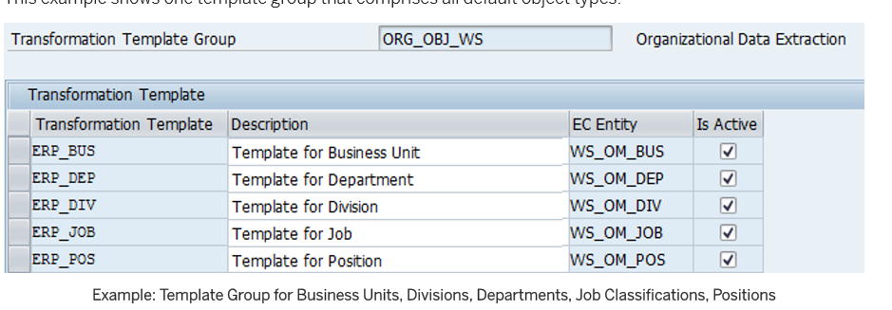

1. Define the transformation template: Create at least one transformation template for your template group.

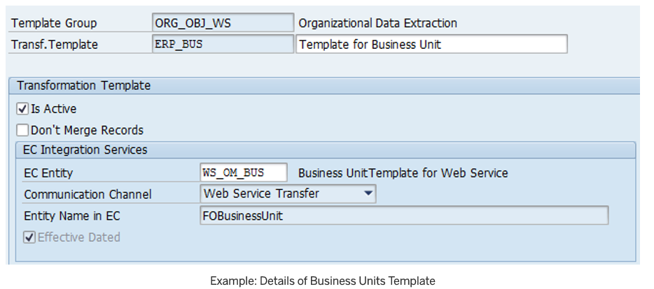

1. **Define the field mapping: In** the Primary Mapping view, you map the Employee Central fields provided by the Employee Central entity to SAP ERP HCM fields.
2. **Optional step – Define the conditional mapping**: In the Secondary Mapping view, define your conditional mapping if required (see below for details).

**Formatting Employee Central Fields Using Value Conversion**

Generic value conversion will be use to format the value of Employee Central fields used in organizational data replication, before the primary field mapping and the value mapping are processed in SAP ERP HCM.

Here's how to define generic value conversion:

1. Go to Customizing for Personnel Management and choose Integration with SuccessFactors Employee Central Business Integration Builder Organizational Data Integration Define Field Mapping for Organizational Data Primary Mapping .
2. Map an Employee Central to an SAP ERP HCM field, using the Infotype Mapping mapping mode.
3. Select your entry, go to the Generic Value Conversion view in the same Customizing activity, and make the following entries:

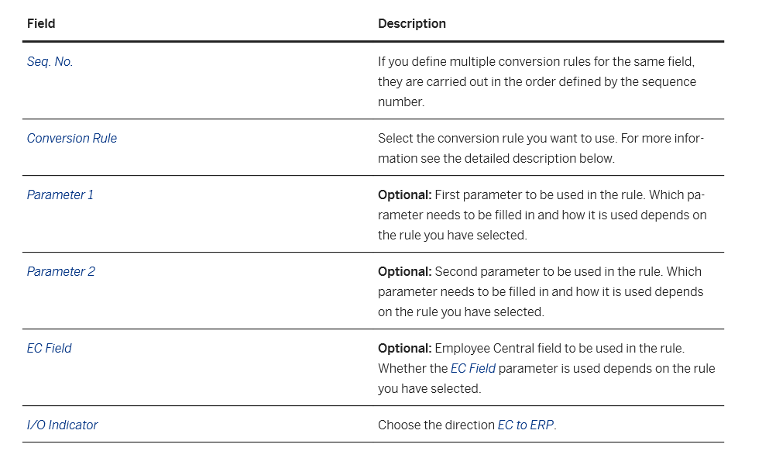

The following conversion rules are available:

* Multiply with a number

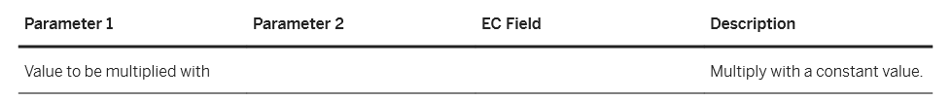

* Replace using patterns with string or Employee Central field

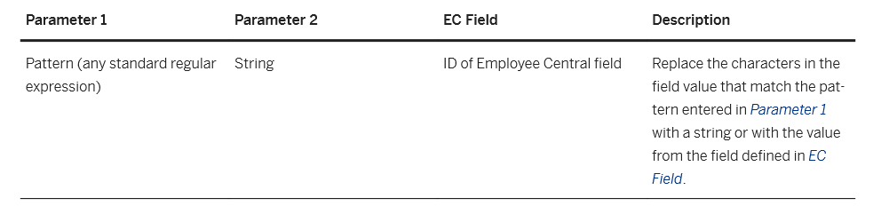

* Append string or Employee Central field

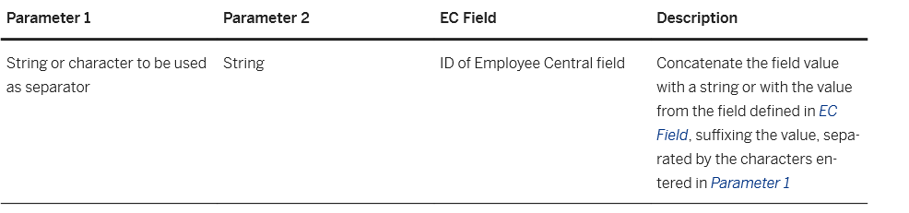

* Adjust string to length

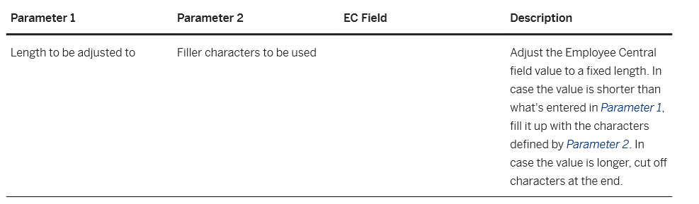

* Prepend string or Employee Central field

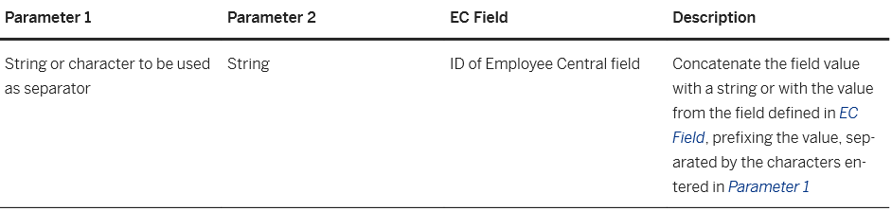

* Replace with string or Employee Central field

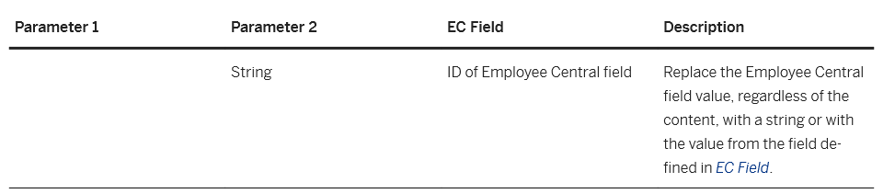

* Split before string or character

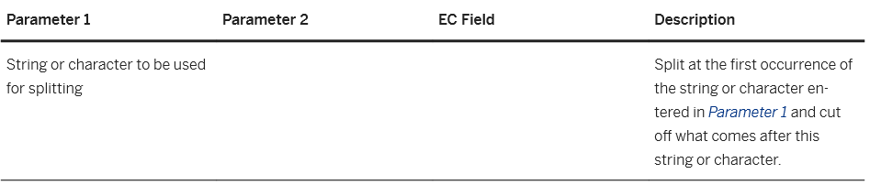

* Edit using pattern

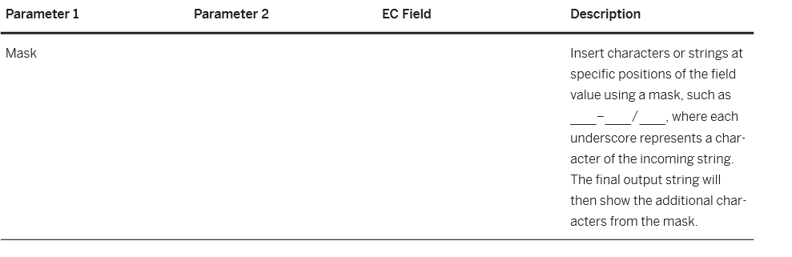

* Check and replace

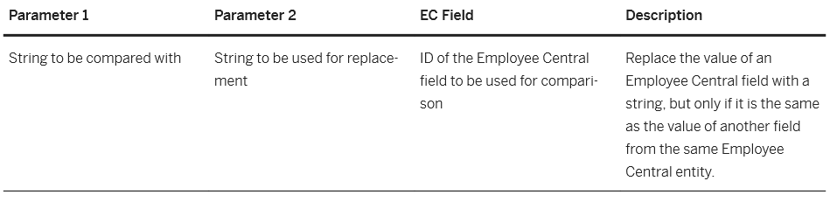

* 1. Middleware: SAP Cloud Platform Integration

**Connecting to SAP CPI**

A dedicated SAP CPI user is required to serve as the Integration User which will be used to call exposed webservices deployed in SAP CPI. To enable SAP ERP HCM to process messages on a tenant using HTTPS/basic authentication, the Integration user requires the role ***ESBmessaging.send***.

**Securing communications**

To enable secure HTTPS communication between SAP ERP HCM and SAP CPI, the root certificate of SAP CPI needs to be stored in the Trust Manager (transaction STRUST) in SAP ERP HCM.

For connections initiated by SAP Cloud Platform Integration to the SAP ERP HCM system, the root certificate from the SAP ERP HCM system needs to be added in the keystore in the SAP Cloud Platform Integration tenant.

**Deploying Security Artefacts**

To communicate with other systems, a security artefact needs to be deployed in the SAP CPI tenant for each of the system/instance SAP CPI will connect with. The SAP ERP HCM Data Replication user and the Successfactors Integration User is required to have a security artefact created (and deployed) so it could be utilized in the Integration flow deployment. Both users should have the permissions or authorizations as have been stated on previous sections of these document.

**Deploying Integration Flows**

The standard SAP SuccessFactors Employee Central to ERP Employee and Organizational Data Integration Package contains 2 Integration flows in SAP Cloud Platform Integration which are both required to be deployed. This package needs to be copied into the TENNECO’s CPI tenant to be utilized for data replication.

1. SAP SuccessFactors Employee Central to ERP Employee Data and Organizational Assignment
   1. Configure the sender, **ERP_Query**, which is used by the SAP ERP HCM system to send the query to the middleware:

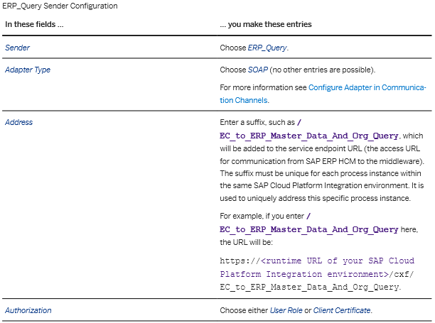



* 1. Configure the **Employee_Central** receiver, which is used by the middleware to request the queried data from Employee Central

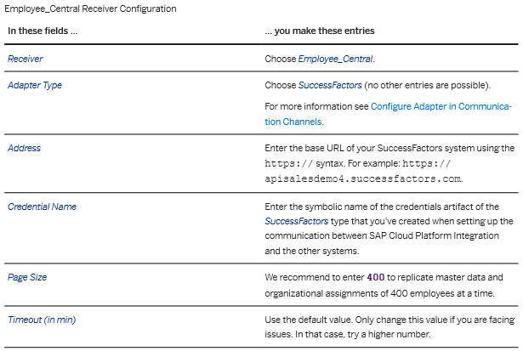

* 1. Configure the **ERP_Response** receiver, which is used by the middleware to send back the queried data from Employee Central to the SAP ERP HCM system

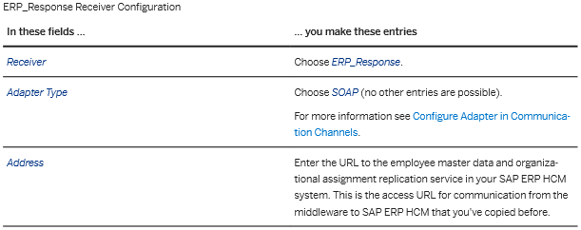 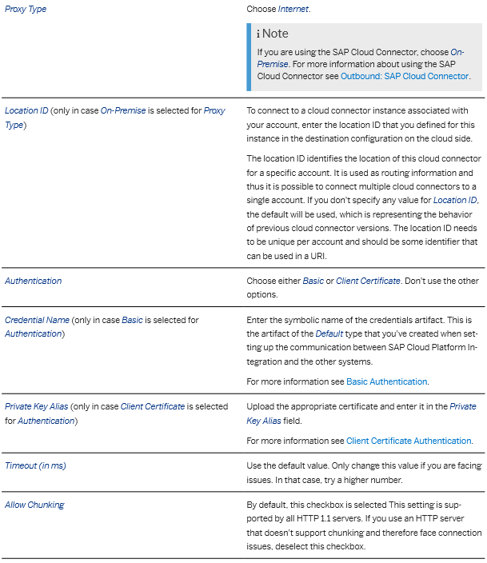

* 1. Make the same settings for the **ERP_Notification** receiver as for the **ERP_Response** receiver. **ERP_Notification** is used by the middleware to send notifications about the status of the query in Employee Central to the SAP ERP HCM system
  2. Make the same settings for the **ERP_Exception_Notification_Main** receiver as for the **ERP_Response** receiver. **ERP_Exception_Notification_Main** is used by the middleware to send error messages to the SAP ERP HCM system
  3. Make the same settings for the **ERP_Exception_Notification_Sub** receiver as for the **ERP_Response** receiver. **ERP_Exception_Notification_Sub** is used by the middleware to send error messages to the SAP ERP HCM system.

***URLs and Credentials for Integration Flow parameters***

|  |  |  |
| --- | --- | --- |
| **Receiver** | **URL** | **Credentials** |
| ***ERP_Query*** | | |
| Development: |  |  |
| Test: |  |  |
| Production: |  |  |
| ***Employee_Central*** | | |
| Development: |  |  |
| Test: |  |  |
| Production: |  |  |
| ***ERP_Response*** | | |
| Development: |  |  |
| Test: |  |  |
| Production: |  |  |
| ***ERP_Notification*** | | |
| Development: |  |  |
| Test: |  |  |
| Production: |  |  |
| ***ERP_Exception_Notification_Main*** | | |
| Development: |  |  |
| Test: |  |  |
| Production: |  |  |
| ***ERP_Exception_Notification_Sub*** | | |
| Development: |  |  |
| Test: |  |  |
| Production: |  |  |

1. SAP SuccessFactors Employee Central to ERP Generic Object
   1. Configure the sender, **SAP_ERP_OUT**, which is used by the middleware to get the query sent by the SAP ERP HCM system

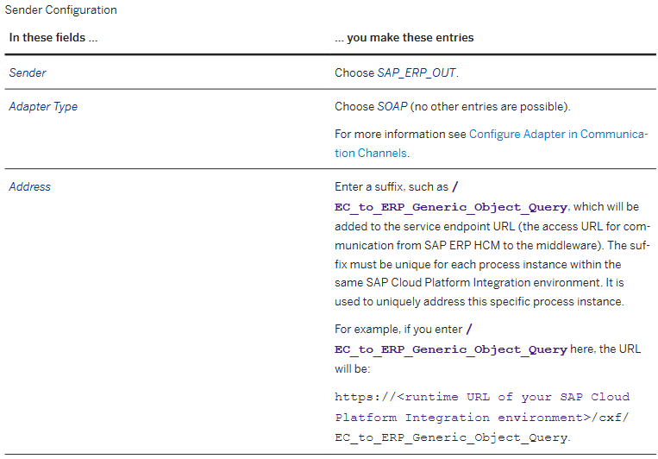

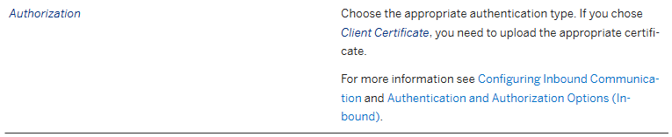

* 1. Configure the SFSF_EC receiver, which is used by the middleware to request the queried data from Employee Central

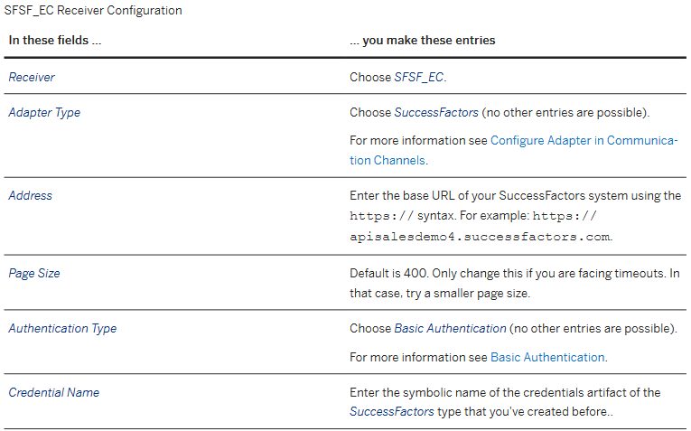

* 1. Configure the ***SAP_ERP_IN*** receiver, which is used by the middleware to send back the queried data from Employee Central to the SAP ERP HCM system

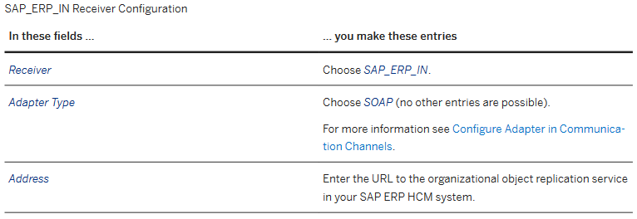

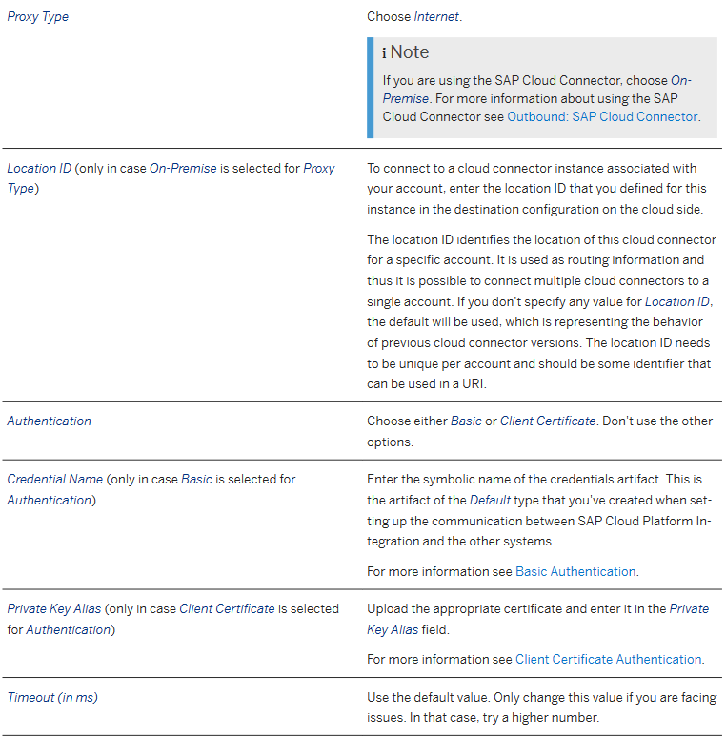 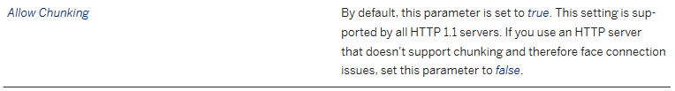

* 1. Configure the ***SAP_ERP_Notification_IN*** receiver, which is used by the middleware to send notifications about the status of the query in Employee Central to the SAP ERP HCM system

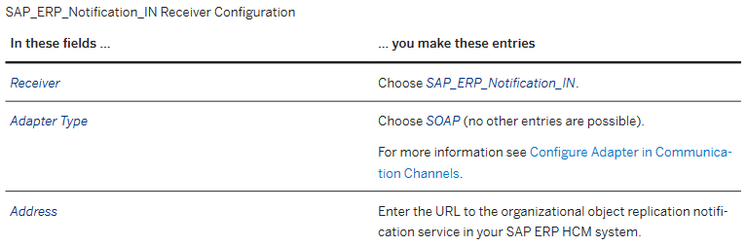

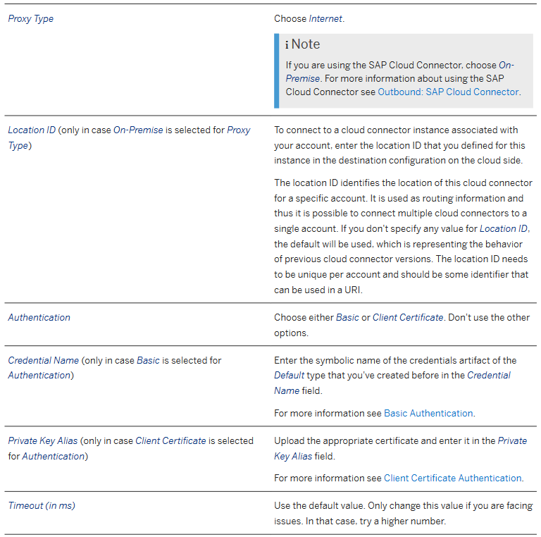 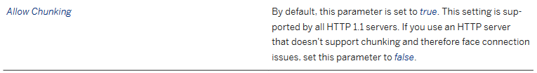

* 1. Make the same settings for the ***SAP_ERP_Exception_Notification_IN*** receiver as for the ***SAP_ERP_Notification_IN*** receiver

***URLs and Credentials for Integration Flow parameters***

|  |  |  |
| --- | --- | --- |
| **Receiver** | **URL** | **Credentials** |
| ***SF_EC*** | | |
| Development: |  |  |
| Test: |  |  |
| Production: |  |  |
| ***SAP_ERP_IN*** | | |
| Development: |  |  |
| Test: |  |  |
| Production: |  |  |
| ***SAP_ERP_Notification_IN*** | | |
| Development: |  |  |
| Test: |  |  |
| Production: |  |  |
| ***SAP_ERP_Exception_Notification_IN*** | | |
| Development: |  |  |
| Test: |  |  |
| Production: |  |  |

* 1. Field & Value Mapping



* 1. Tables, Programs, Execution & Monitoring

***SAP Tables***

| **Table** | **Function** |
| --- | --- |
| SFIOM_RPRQ_EE | Staging table for replication requests for employee organizational assignments |
| SFIOM_RPRQ_EOAXT | Staging table for replication requests for employee organizational assignments |
| SFIOM_RPRQ_JOBRS | Staging table for replication requests for employee organizational assignments |
| SFIOM_RPRQ_ORGAS | Staging table for replication requests for employee organizational assignments |
| SFIOM_GENRQ_HD | Staging table for replication requests for Organization Objects |
| SFIOM_GENRQ_DP | Staging table for replication requests for Organization Objects |
| SFIOM_GENRQ_DFLD | Staging table for replication requests for Organization Objects |
| ECPAO_PIKLST_ENT | Picklists Imported from Employee Central |
| ECPAO_PIKLST_VAL | Picklist Values Imported from Employee Central |
| ECPAO_REFPIK_ENT | Reference Picklists Imported from Employee Central |
| ECPAO_REFPIK_VAL | Reference Picklist Values Imported from Employee Central |
| V_ECPAO_COMPANY | View Table for Employee Central Company ID |
| V_ECPAO_FLD | View Table for Employee Central Fields |
| VC_ECPAO_MAP | View Cluster for Mapping Tables |
| V_ECPAO_TEMPLSET | View Table of Template Mapping |
| V_ECPAO_ERPTEMPL | View Table of Primary Mapping |
| V_ECPAO_FLDMAP | View Table of Field Mapping |
| SFIOM_KMAP_OSI | Key Mapping Table |
| SFIOM_QRY_ADM | Administration of Organizational Object Query |

***Programs***

|  |  |
| --- | --- |
| **Programs** | **Function** |
| RH_SFIOM_PROC_EE_ORG_ASS_RPRQ | Replicate Employee Org. Assignments from EC to ERP Org. Mgmt |
| ECPAO_EE_ORG_REPL_QUERY | Create and Execute Employee Master Data and Org. Assignment Query |
| ECPAO_ECTMPL_METADATA_WRITER | Import of Metadata from Employee Central Using XML File |
| ECPAO_PICKLIST_WRITER | Import of Picklists from Employee Central |
| ECPAO_RESET_QRY_ADM | Reset Query Administration Table |
| RH_SFIOM_DEL_EE_ORG_ASS_RPRQ | Delete Employee Org. Assignment Replication Requests |
| RH_SFIOM_ORG_OBJ_REPL_QUERY | Create and Execute Organizational Object Replication Query |
| RH_SFIOM_PROC_ORG_STRUC_RPRQ | Replicate Org Objects from EC to ERP Org. Mgmt |

***Jobs***

| **Job Name** | **Program** | **Variant** | **Function** | **Frequency** |
| --- | --- | --- | --- | --- |
| TBD | ECPAO_EE_ORG_REPL_QUERY | TBD | Initiate Query for Employee & Org Assignment Replication | TBD |
| TBD | RH_SFIOM_PROC_EE_ORG_ASS_RPRQ | TBD | Process Org Assignment | TBD |
| TBD | RH_SFIOM_ORG_OBJ_REPL_QUERY | TBD | Initiate Query for Org Object Replication |  |
| TBD | RH_SFIOM_PROC_ORG_STRUC_RPRQ | TBD | Process Org Objects |  |

***SAP Transactions for Monitoring***

| **Transaction** | **Function** |
| --- | --- |
| SM37 | Job Monitoring |
| SLG1 | Analyze Application Logs |
| PA20 | View Employee Data for Validation |
| PP02 | View Organization Data |

* 1. Maintenance

***SAP: Transactions***

| **Transaction** | **Function** |
| --- | --- |
| SM37 | Job Monitoring |
| SLG1 | Analyze Application Logs |
| SRTUTIL | Webservice Trace Log |
| ST01 | Transaction Trace Logs |
| SE80 | ABAP Object Explorer |
| PA20 | View Employee Data for Validation |
| PP02 | View Organization Data for Validation |
| SE16 | Table View |

***SAP CPI: Monitoring***

|  |  |
| --- | --- |
| **IFlow** | **Function** |
| TBD | Employee Data Replication |
| TBD | Org Object Replication |

***SuccessFactors***

|  |  |
| --- | --- |
| **Menu** | **Function** |
| Data Replication Monitor | Employee Replication Monitoring tool |
| SFAPI Audit Log | Audit Log for Integration via SFAPI |

1. Connection
   1. SuccessFactors Employee Central

| **EC API** | ODATA/SFAPI |
| --- | --- |
| **Development** |  |
| **QA/Test** |  |
| **Production** |  |

* 1. SAP ERP HCM

| **SAP Webservice** |  |
| --- | --- |
| **Development** |  |
| **QA/Test** |  |
| **Production** |  |

* 1. SAP Cloud Platform Integration

| **SCPI IFlow Name** |  |
| --- | --- |
| **Development** |  |
| **QA/Test** |  |
| **Production** |  |

1. Sample Files

<Will be provided once SAP CPI access is acquired>

1. Project Definition
   1. Project Name

|  |  |  |
| --- | --- | --- |
| **Project Name** | **Source Database** |  |
| TENNECO | SuccessFactors Employee Central |  |

* 1. Migration Requirements

Data migration requirements from SAP ERP HCM to SuccessFactors will be managed separately. However, the first execution of this interface would initiate creation of new records in SAP ERP HCM. These will serve as the baseline of the replication records. If historical records will not be migrated in EC, a pre-migration exercise would be required to split all currently valid infotype records in SAP ERP HCM to preserve these records dated prior to the set Full Transmission Start Date (FTSD).

1. Appendix
   1. Infotype Data Handling Reference



1. Open Items
2. (BIB) Update mapping once configuration has been completed for fields pending in EC
3. (BIB) Validate values that are not mapped from source to target – either Not in EC or no corresponding values in SAP
4. (BIB) Define Full Transmission Date for all 4 systems
5. (ABAP) Mapping for Poland – Gdansk in HPC
6. (ABAP) Personal Data Mapping for Contingent Workers in all 4 systems
7. (Design) EC Business Process for notifications